Kanaloa / Tutorials / Light Buoy

**Light Buoy**

**Tutorial references:**

RobotX

* Light Buoy Preliminary Specifications
* Task Descriptions and Specifications

Kanaloa Journal Paper

Paul for his Solid Works Model to hold PVC pole

Yong for his LED lights

Charmaine and Kekoa for umbrella

Cheyenne for help on the cylinder

Home Depot 5-gallon bucket specifications

The purpose of this tutorial is to create a light buoy that may be read by scan the code color recognition sensors from the WAM-V. One of the 2018 RobotX challenges is for the WAM-V to record the location and color of a light source from a floating buoy. These colors are red, green, and blue. Two separate projects will be considered in the overall light buoy design: How to create a light pole, and how to create a floating platform to support this light pole.

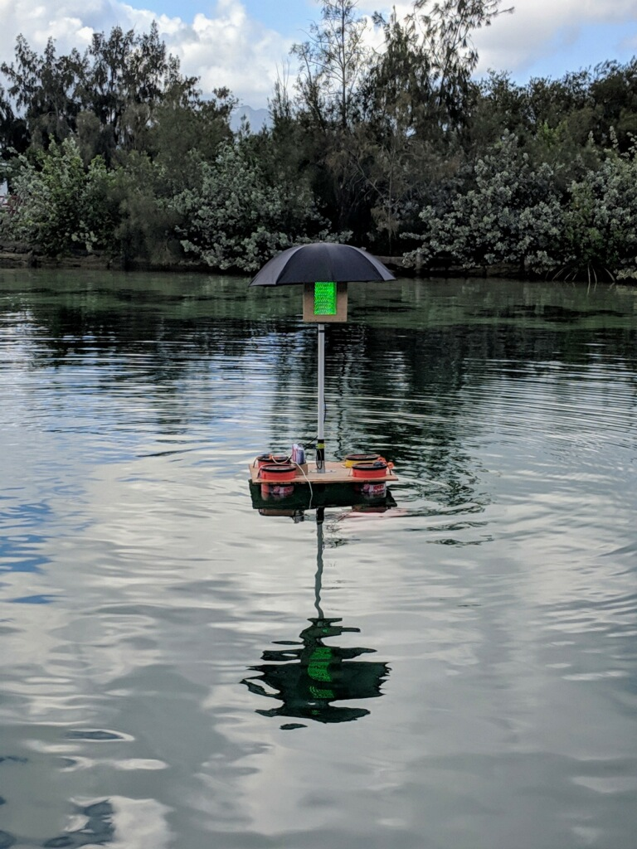

Figure 1: Final Design of Light Buoy

**Create a light pole**

**Construct wooden triangular frame:**

1. Buy three ¼ inch thick plywood of 15” x 20”.

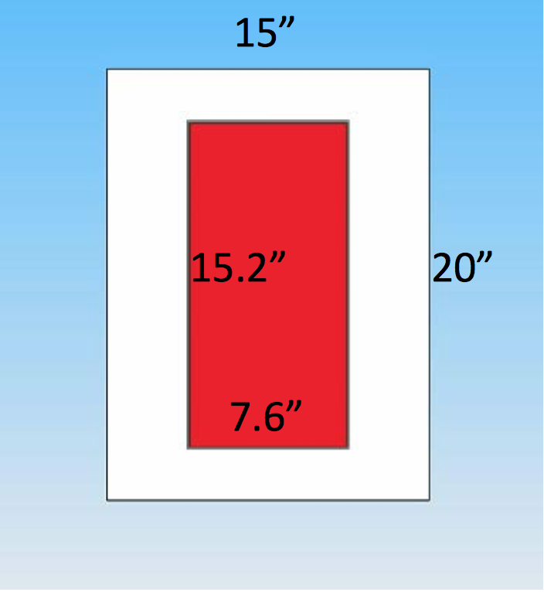

Figure 2: Dimensions for Wooden triangular panel

2. Use a power drill to create a hole in the middle of the wood.

3. Use a jigsaw to cut a 15.2” x 7.6” hole.

4. Repeat two more times.

5. 3D print twelve V-shaped corners approximately 1 inch high, ¼ inch thick, and 2 inches wide on each side of the V. Print two ¼ inch diameter holes on each side of the V (a total of 4 holes for each V).

6. Use forty-eight ¼” diameter zinc hex shaped fasteners that are ¾” long to attach V-shaped corners to each wooden frame. Use associated 48 zinc washers and nuts to fit over the fasteners.

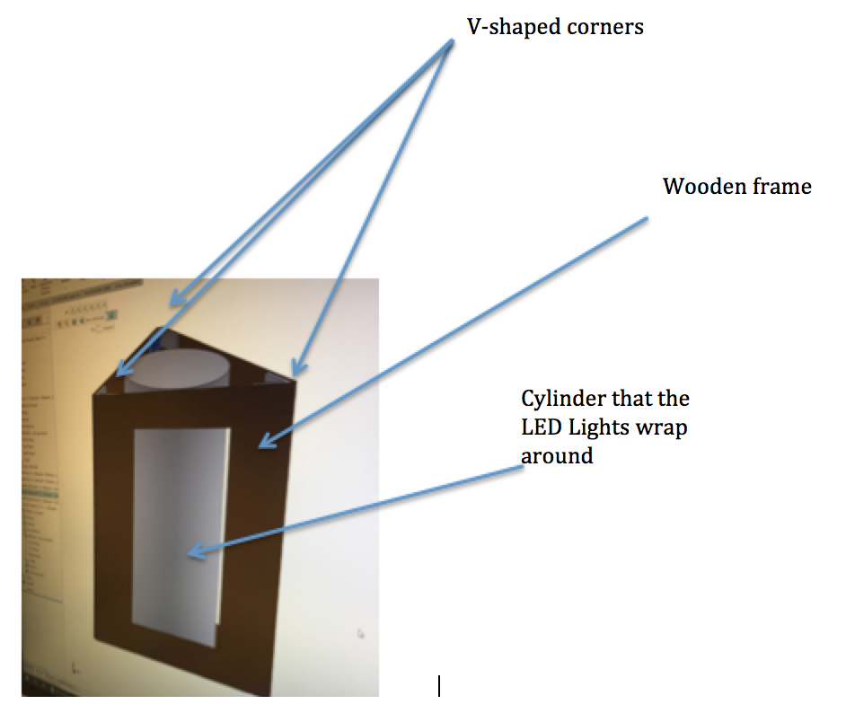

Figure 3: Model of three wooden panels fitting together with V-shaped 3D parts and cylinder

7. Use ¼ inch thick plywood and cut two 15” equilateral triangles with a jigsaw. Find the center of the triangle and cut a 2” diameter hole from the triangles center. The PVC pole will fit through this hole.

8. Connect six 1x1x1 inch wooden blocks to each triangle using a ¼” diameter ¾” long zinc screw for each block. This gives the triangle covers a base to connect to the three rectangular plywood panels.

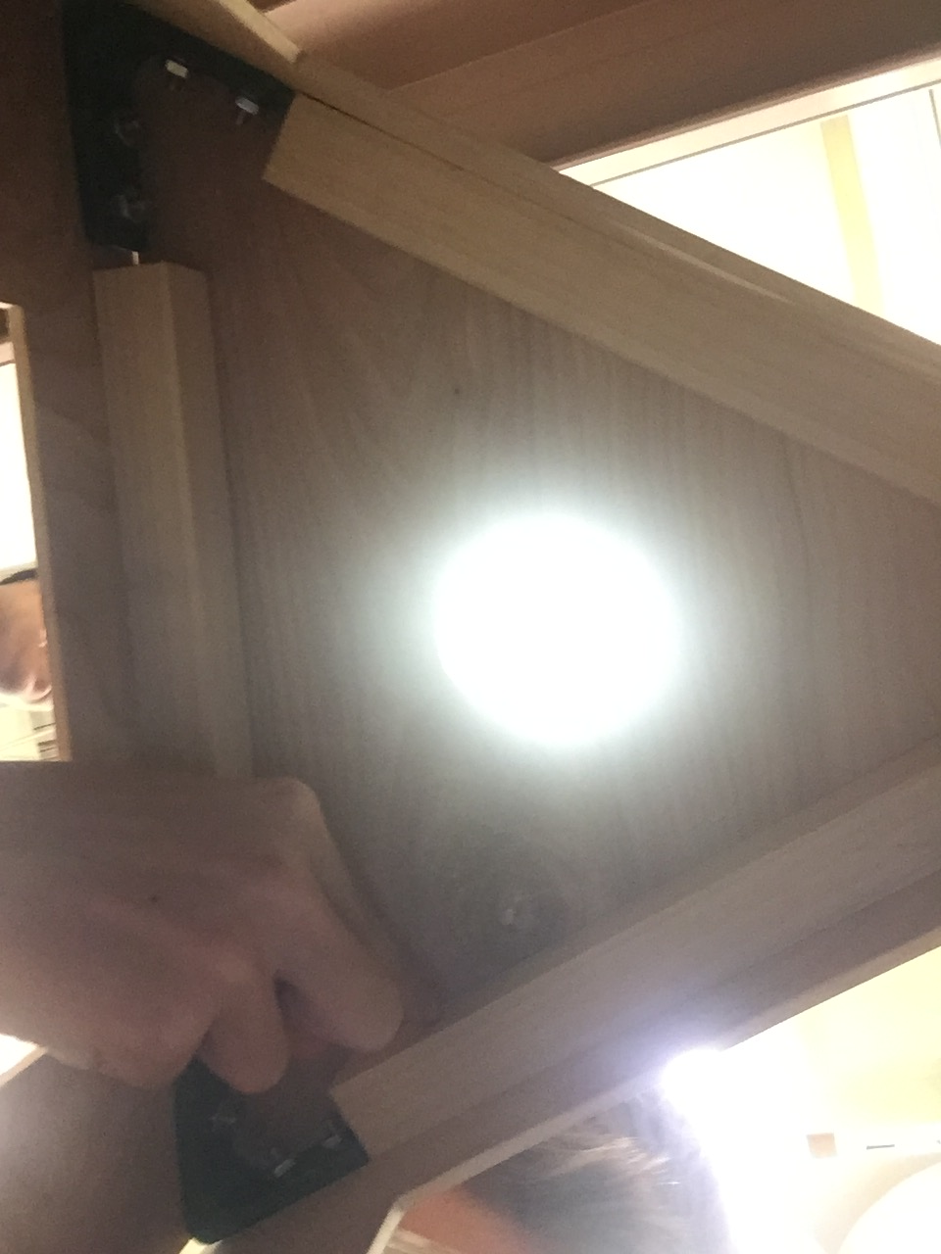

Figure 4: Ground-up perspective inside triangular wooden frame. Shows cut circle with triangle cover supported by 1 inch thick blocks of wood to act as a base.

**PVC Pole:**

9. Buy a 1.5 inch outer diameter PVC pole 6 feet tall. The PVC pole is 6 feet tall because RobotX specifies the top edge of wooden panel is no more than 9.8 feet above the water surface.

**Holding PVC Pole:**

10. Model in Solid Works a design to hold a 1.5 inch outer diameter PVC pole. The model and dimensions for this design can be found in the uploaded file. See figure 5.

11. Use a ¼” zinc fastener (no washer or nut required) and twist into 3D shape to secure 1.5” PVC pole to 3D printed shape.

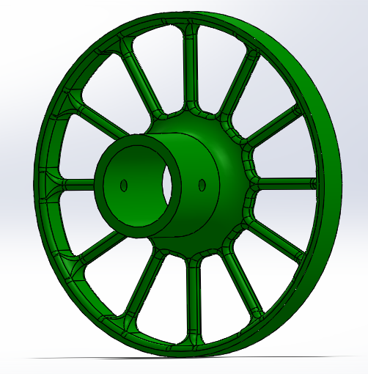

Figure 5: Solid Works Model to hold PVC pole and Cylinder

**Construct Cylinder:**

12. Using a polyethylene plastic sheet cut a 25” by 19.5” rectangle. The circumference of the cylinder will be 25” and the height will be 19.5”.

13. Apply super glue on outer edge of 3D printed model shown in figure 6.

14. Wrap the plastic sheet around the outer edge of this model in figure 6.

15. Use duct tape to hold plastic together while super glue dries.

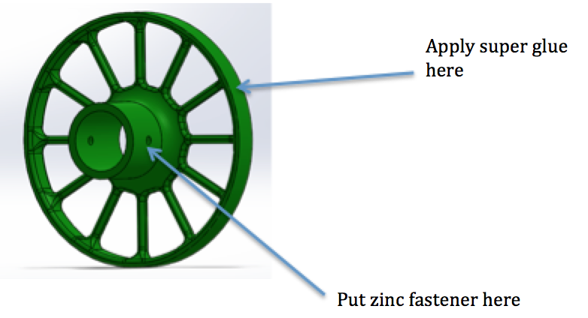

Figure 6: Explanation for how to secure PVC and cylinder to 3D part

**Electronics:**

16. Attach approximately 90 feet of LED lights to plastic cylinder using a spray adhesive. Be sure to leave no gaps between each strip of LED to maximize brightness.

17. Run wires that power LED lights through PVC pole and through wooden plywood as seen in figure 7.

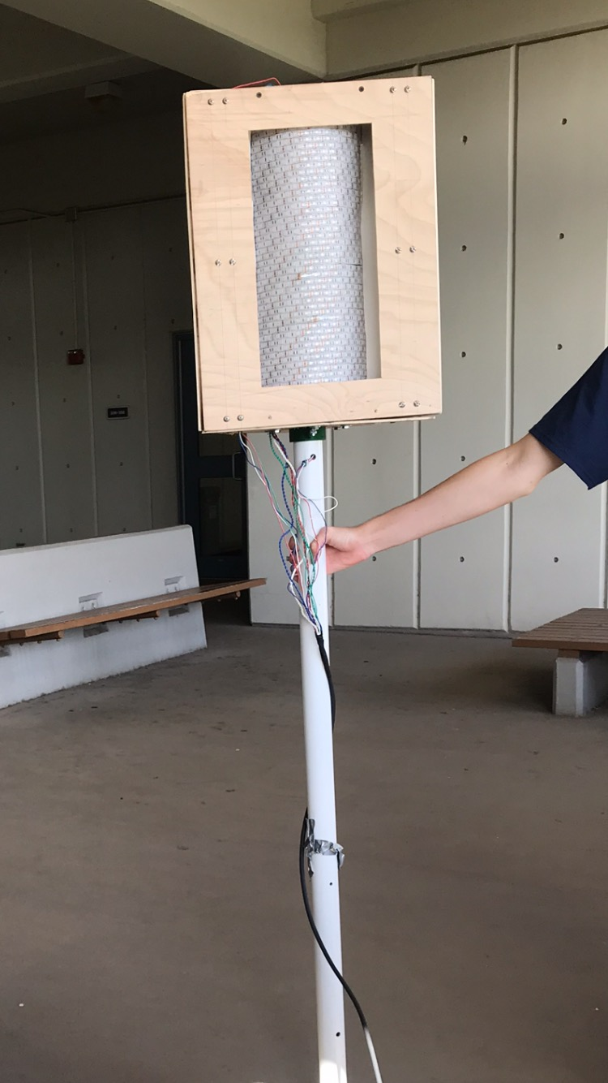

Figure 7: Head on view of light pole showing where wires run on pole

**Storing electrical components:**

18. Use a husky box to fit electrical components. See Yong’s technical documentation for what electrical components go inside husky box. The box will rest on the platform of the buoy for easier assembly.

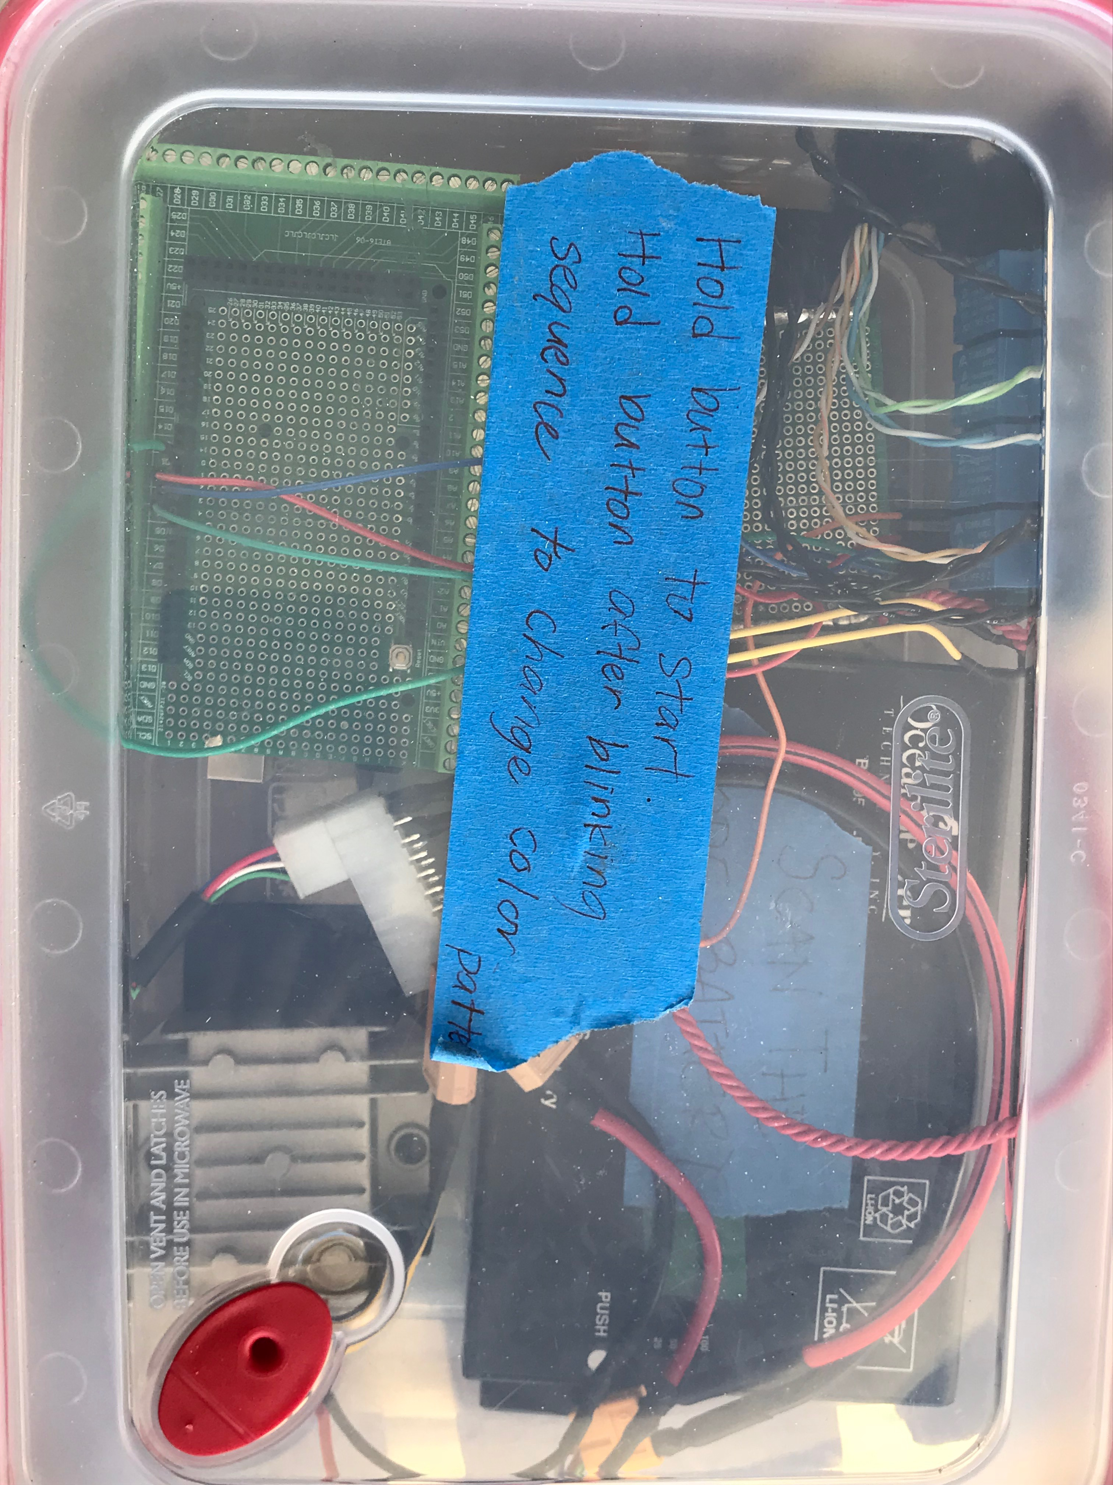

Figure 8: Electrical components inside husky box to power LED lights on light pole

**Shade the LED lights:**

19. Use a black umbrella and place handle inside of PVC pole from the top of the light pole. Tape the umbrella to the PVC with duct tape. The purpose of using an umbrella is to provide shade for the light buoy to brighten LED colors.

**Create a floating platform for light pole**

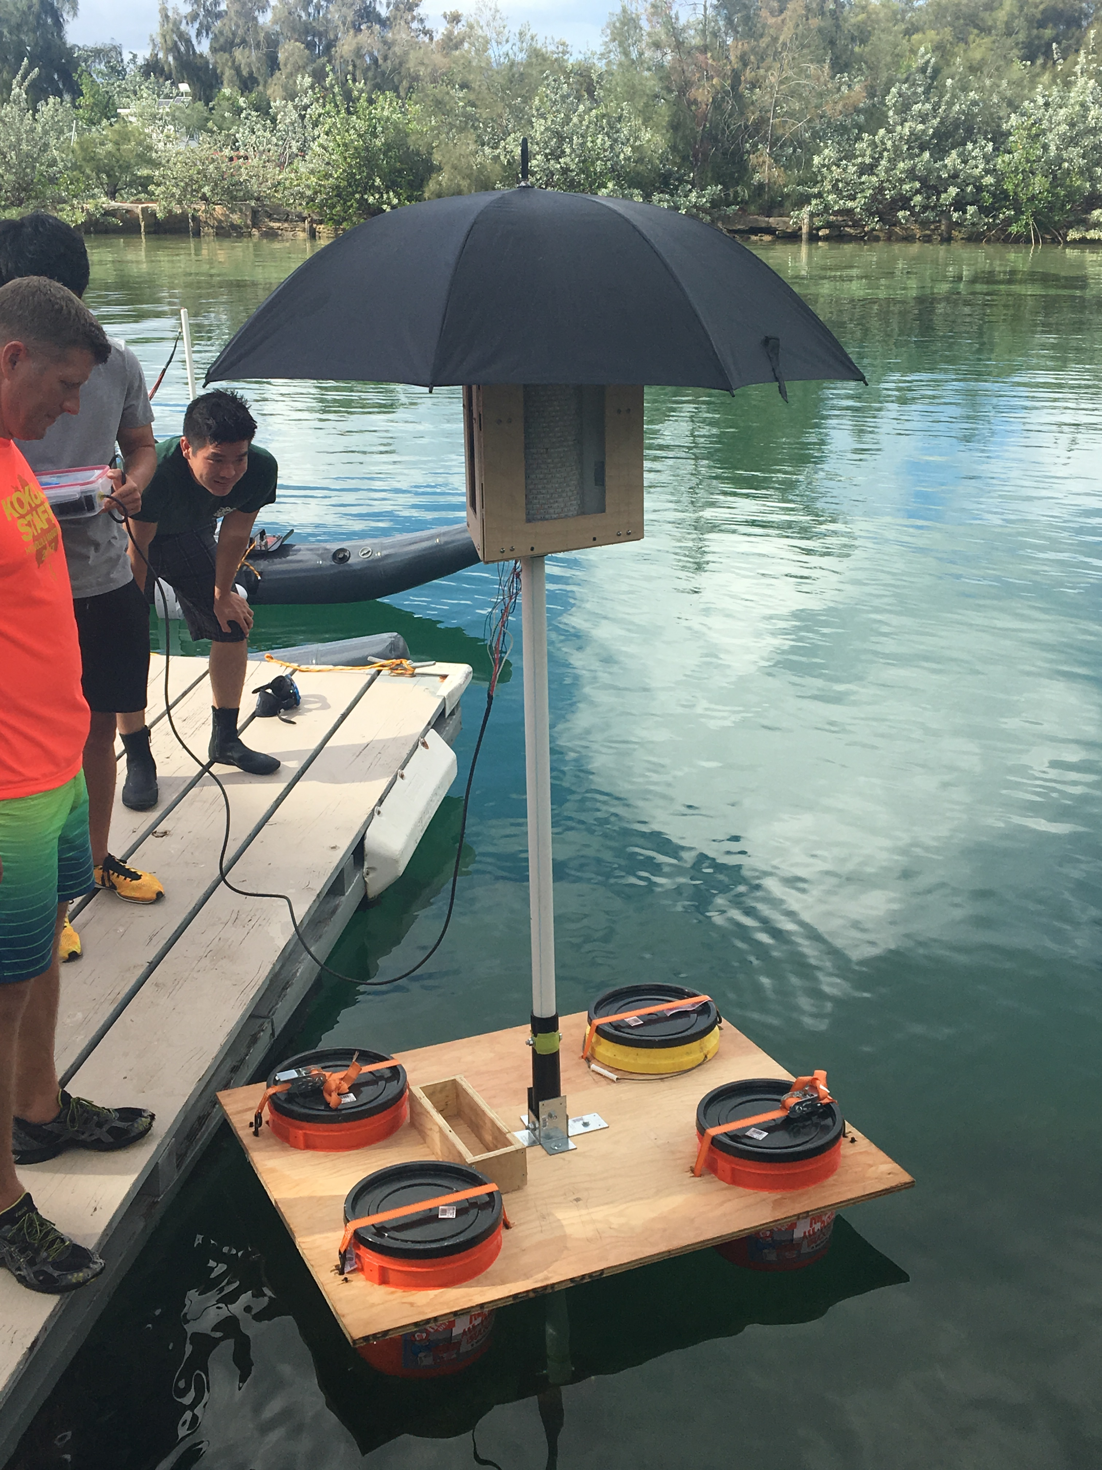  
Figure 9: Finished floating platform

The purpose of this floating platform is to allow the light pole to float in the water.

**Materials for floating platform:**

* Four 5 gallon buckets with black screw top bucket lid
* Wooden platform
* 5 lb weights attached to bottom of platform. 35 – 40lb total weight
* Two ratchet straps
* Four L-shaped aluminum corners to secure the PVC pole to platform

1. Select 1-inch thick plywood that is approximately 50 inches x 50 inches square.

2. On the plywood platform, draw a line 3 inches away from each edge of the platform. Use compass to draw a circle 11.5 inches in diameter. Draw these circles for all four corners of the platform. A 5-gallon home depot bucket has a maximum product diameter of 12 inches, so we make a circle of 11.5 inches to sit on the platform without slipping through.

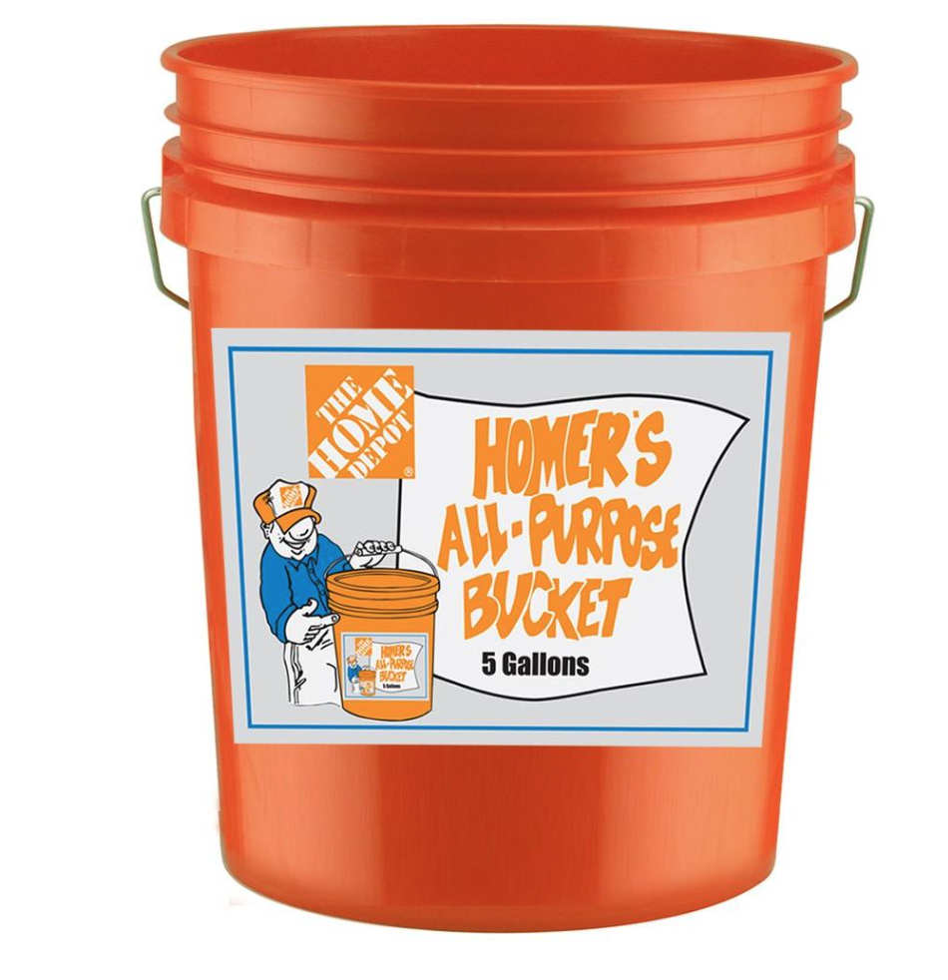

Figure 10: Image of 5-gallon bucket used with link to product provided.

<https://www.homedepot.com/p/The-Home-Depot-5-Gal-Homer-Bucket-05GLHD2/100087613>

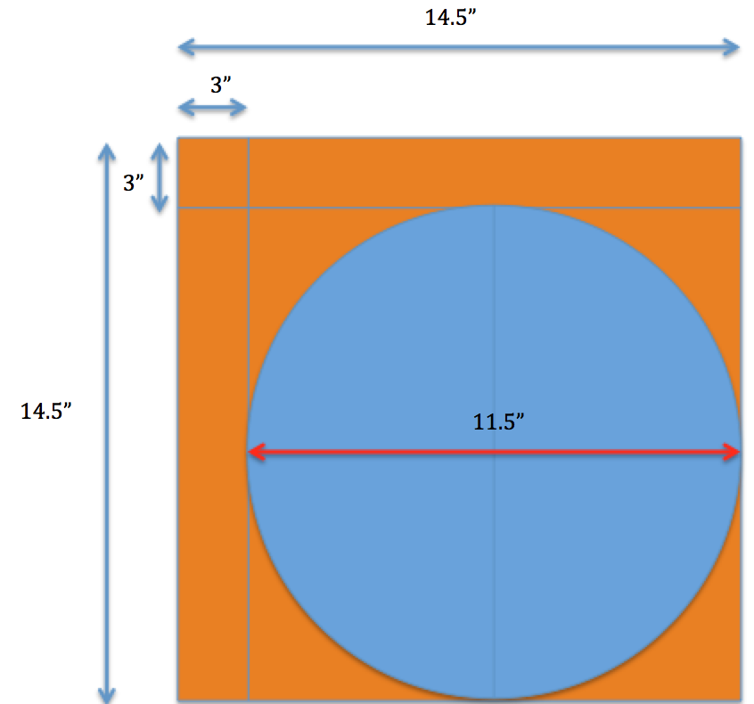

Figure 11: Dimensions for diameter of circle to be cut from floating platform

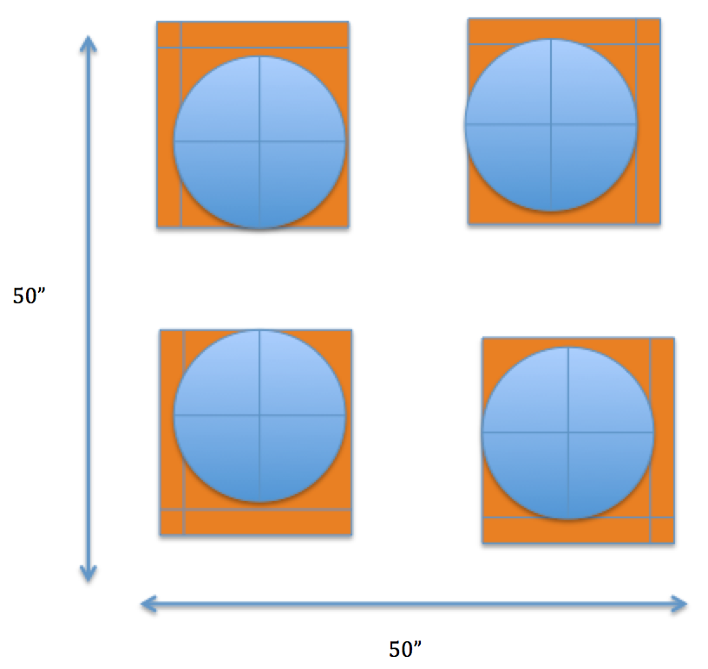

Figure 12: Zoomed out view of where four buckets fit on the floating 50”x50” platform.

3. Use a jigsaw to cut a circular hole and place a 5-gallon bucket inside each hole.

**Calculate amount of buoyant force:**

Approximately 3 gallons will be under water. There is 8 lbs of upward force acting on an object per gallon, and 4 buckets total. (8lbs/gal)*(3gal)*4 = 96 lbs. of buoyant force.

4. Cut a circle in center of platform approximately 1.5 inches in diameter.

Attach four L-shaped aluminum corners to secure the PVC pole to platform. Use zinc fasteners to attach to pole and platform.

5. Use two ratchet straps to secure buckets to platform. Each strap supports two buckets.

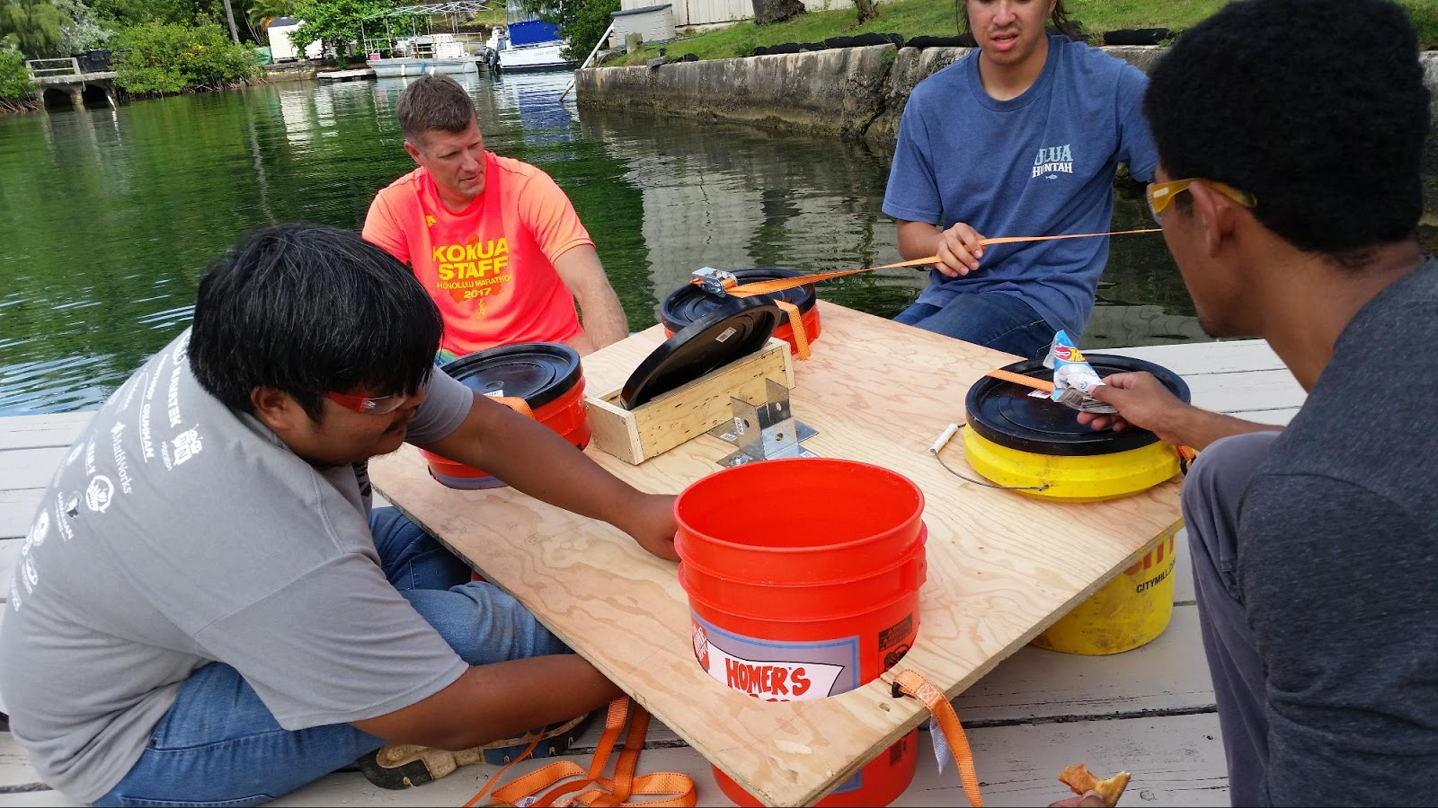

Figure 13: Assembly of floating platform. Securing buckets with ratchet straps

6. Add 5 lb weights attached to bottom of platform. A total of 35 – 40lb total weight.